University of Pittsburgh at Johnstown
Department of Electrical and Computer Engineering
EE 1195 / COE 1195 Engineering Practice and Professional Development
Functional Requirements and Engineering Specifications

Cycle Statistic Tool

Date: October 2nd, 2020

Submitted By: Jacob Hoffman
Cody Klingler

Instructor: Professor Gabany

Problem Statement:
Current general-purpose activity tracking devices that are available for cyclists do not offer a specific collection of data for cycling statistics tracking. Specialized meters designed for cyclists do not offer a wide range of data, but only specific measurements for the activity. Cyclists require a better, more encompassing solution for setting goals and tracking improvement. The Cycle Statistic Tool is an opportunity to provide an all-in-one solution for cyclists through the use of advancements in technology.

Project Description:
The Cycle Statistic Tool is a data recording device which will be attached to the frame of a bicycle. In this position, several electronic components may be used to record statistics about a user’s cycling trip. The layout of these components can be seen in Figure 1. The Cycle Statistic Tool will transmit data to a companion application that is installed on a user’s smartphone. This app will utilize the collected information to provide records of a user’s cycling sessions in the form of graphs and charts that enable the user to improve their cycling skills. An appropriate Arduino microcontroller will be used as the primary board to connect all sensors and for operation of the device. A secondary Arduino microcontroller will be attached to the pedal shaft to wirelessly relay data from this position to the primary board. Live data will be displayed to the user by a display panel connected to the primary board. The entire device will require a casement which will be modeled and 3D-printed. This casement should be somewhat weather-proof and able to connect to the frame/handlebar of a bicycle universally.

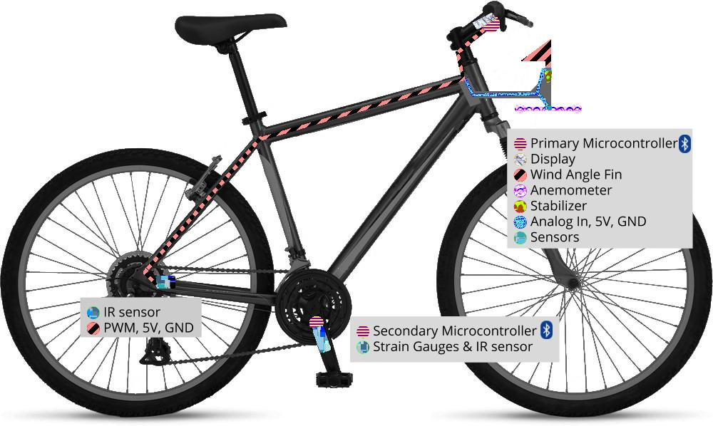
Figure 1: Basic Diagram
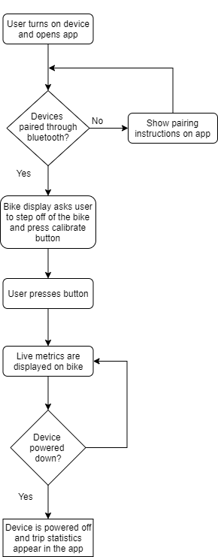
Figure 2: Flowchart

Functional Requirements:
The following functional requirements and their importance were found through the use of a survey targeted towards potential customers. Relative importance to different customer demographics were recorded in Figure 3, Figure 4, and Figure 5 in the form of a House of Quality.

Accuracy of Measurements
The general accuracy of all measurements found by the tool. Current fitness apps are capable of estimating measurements like power, but cyclists require more accurate information.
Attaches Universally
This means the tool can be mounted on most bicycles. Cyclists would prefer to use the bicycle that they own, rather than finding a compatible one.
Ease of Use
Generally refers to the steps needed to connect the device to a phone, the amount of clicks needed to access anything within the app, the amount of steps needed to set the tool up before each use, and ease of configuration. This is important so that cyclists do not feel inconvenienced by using the product.
Statistic Utilities in App
Refers to how many ways the user can visualize or compare the data that they have stored in the app. This gives the cyclist multiple ways to assess their performance.
Price
How much the product will cost. This should be low so that it is affordable for as many audiences as possible.

Weatherproof
How resistant the product will be to water and stray particles. Without weatherproofing, the product could be destroyed by a light rain or the splash of a puddle.
Ease of Setup
Refers to how many steps it takes to attach the product to a bicycle. This is important for cyclists restricted on time or that use multiple bicycles.
Battery Life
How long the product can be used between charging. It needs to last the whole trip in order to record all of the data.
Durability
Refers to how physically robust the product is. Customers would be displeased with a product that breaks or detaches easily.

Engineering Specifications and Targets:

The following engineering specifications are measurable traits of the product that were determined based on the functional requirements of the customers. Their relations between each other and to the functional requirements are illustrated in Figure 1, Figure 3, and Figure 6.

Table 1: Engineering Specifications
Engineering Specification | Unit | Direction | Target | Threshold
Size | m³ | ▼ | .2 | .5
Overall Accuracy of Sensors | % | ▲ | 90 | 60
Accuracy of Power Metric | % | ▲ | 80 | 60
Accuracy of Speed Metric | % | ▲ | 95 | 85
Cost of Materials | $ | ▼ | 500 | 700
Weatherproof | IP | ▲ | 23 | 54
Battery Life | hr | ▲ | 12 | 3
Lifespan | mo | ▲ | 6 | 2
Time to View Metrics in App | s | ▼ | 2 | 6
Setup Steps Before Use |  | ▼ | 3 | 6
Steps to Attach to Bike |  | ▼ | 15 | 40

Size
This refers to the total volume of the product. Smaller is better. This is not a very important metric and was given a high tolerable range. The largest part of the product will be the wind sensing unit
Overall Accuracy of Sensors
How true the sensors are to the quantity they measure. The sensors need to be accurate in order for all of the metrics on the display and in the app to be accurate. Without accurate data, tendencies will be harder to find.
Accuracy of Power Metric
How close the calculated power value is to the actual power output on the bicycle. This metric is also important for indicating the calories burned.
Accuracy of Speed Metric
How close the calculated speed value is to the actual speed of the bicycle. This metric is important for the cyclist to keep pace and is also used in other calculations.
Cost of Materials
This is closely related to the cost of the product. This should be kept low to be affordable, but expensive items can enhance the tool.
Battery Life
Battery life is important for the convenience of the cyclists and so that recording can last the duration of each bicycle trip.
Lifespan
How long it is expected for the product to last with consistent use. This is important for the reputation of the product and customer satisfaction.

Time to View Metrics in App
The time it takes to get into the app is tied to the amount of clicks it takes and the efficiency of the application. This should be low for the convenience of the cyclist.
Setup Steps Before Use
This is the amount of steps including button presses on the device and in the app that it takes to get the product ready before each trip. This does not include the steps it takes to attach the product to the bike. If there are too many steps, the cyclist will be less inclined to use the tool.
Steps to Attach to Bike
The amount of steps it takes to attach the microcontrollers, sensors, and wires to the bicycle. A large amount of steps could make the customer perceive the product as complicated or difficult to use.

Competition:
Currently on the market, there are general-purpose activity trackers, specialized power meters, and smartphone cycling applications. An example of a general-purpose activity tracker is the Fitbit. The device does well at providing a general activity tracking experience for the user with great ease of use between the device and the app. Additionally, the device has a fair price, is easy to set up, is universal to any user’s wrist, has great battery life, and is waterproof. However, the device lacks measurement accuracy and does not provide specialized measurements for cycling. Specialized power meters make up for this, but tend to lack a wide variety of data collection for the user. For example, the Stages Power Meter offers specialized data about cycling, but the range of data collected is small. Additionally, the Stages Power Meter does not provide an easy set up, has moderate battery life, and is only available at a high price point. Finally, an example of a smartphone cycling application is the Strava Fitness App. The app offers general-purpose activity tracking, similar to the Fitbit, but with data more specific to cycling. Also, the app is free, easy to set up, and user-friendly. However, the app is dependent on the hardware of the user’s phone for features such as data tracking, waterproofing, battery life, and durability. Simply put, if the user does not have a high-end phone, then the experience will not be as good with this solution. The features of these products are compared in Figure 5.
House of Quality:

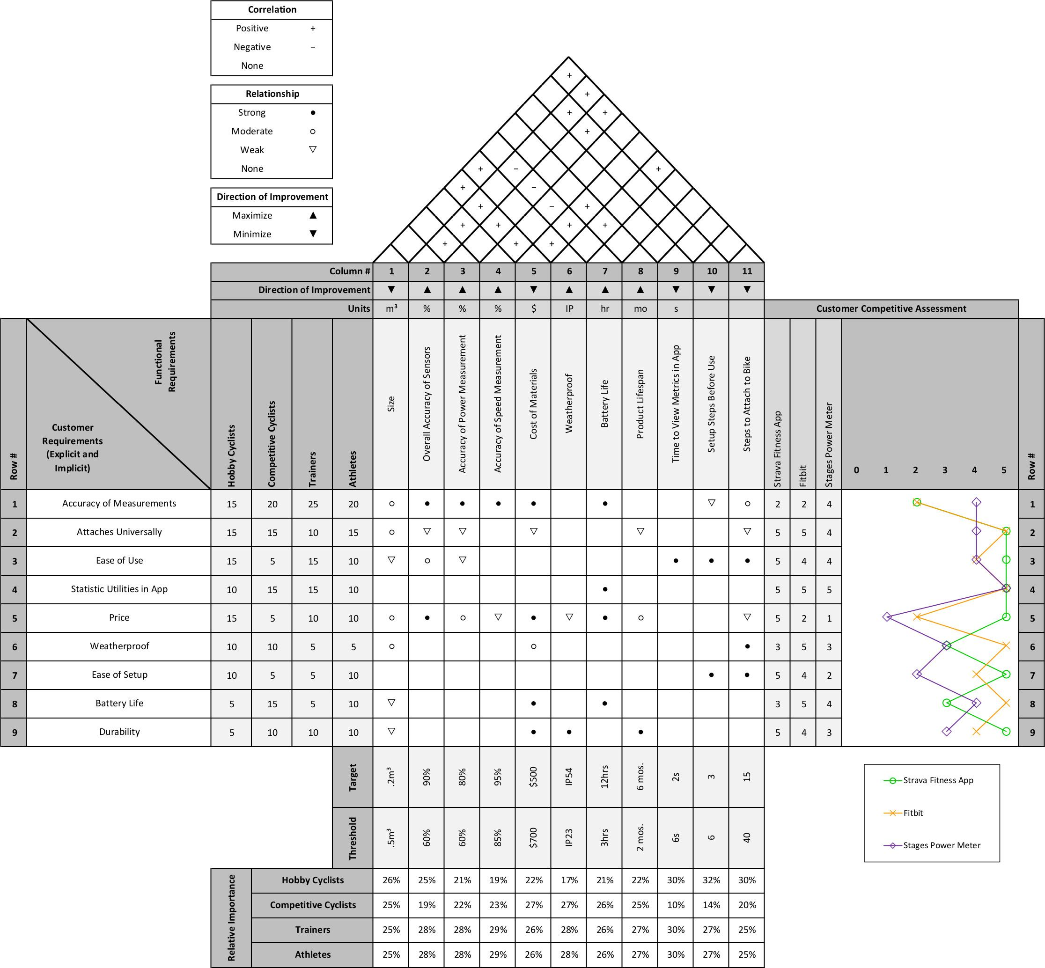
Figure 3: House of Quality

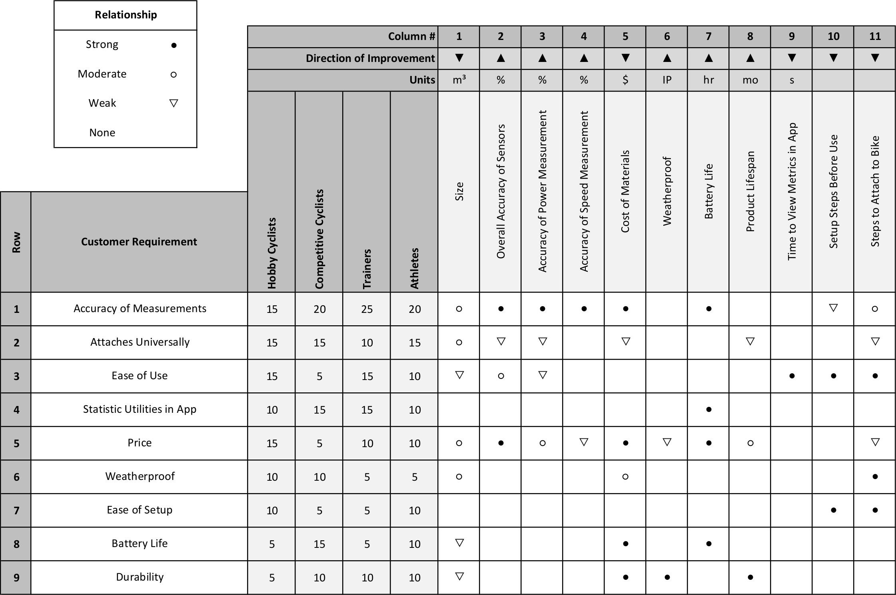
Figure 4: House of Quality (center view)

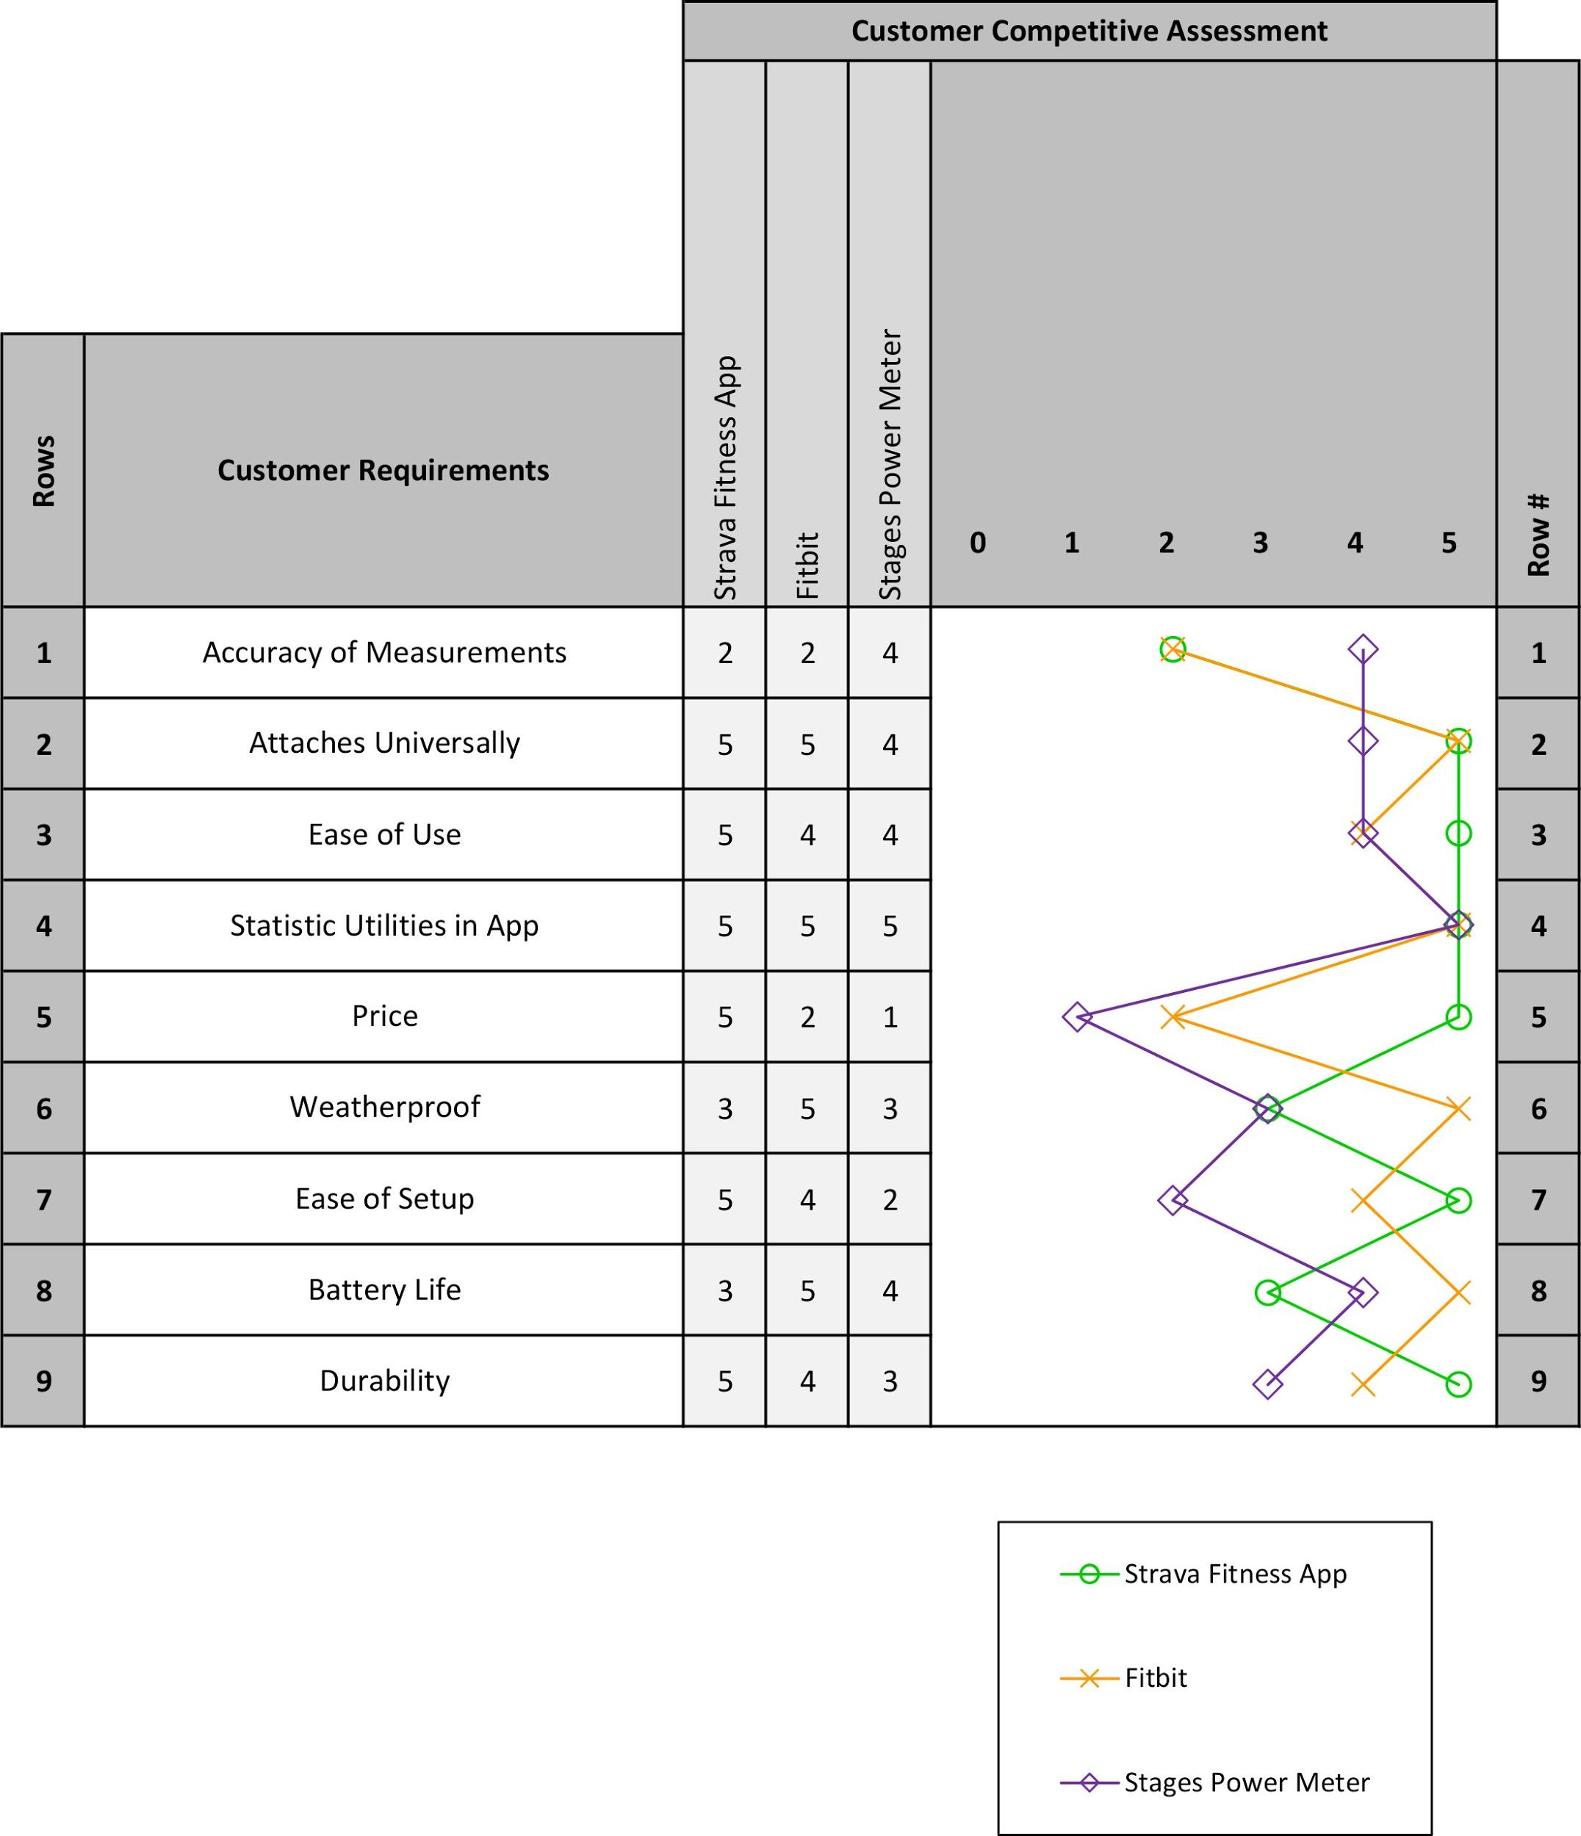
Figure 5: House of Quality (assessment view)

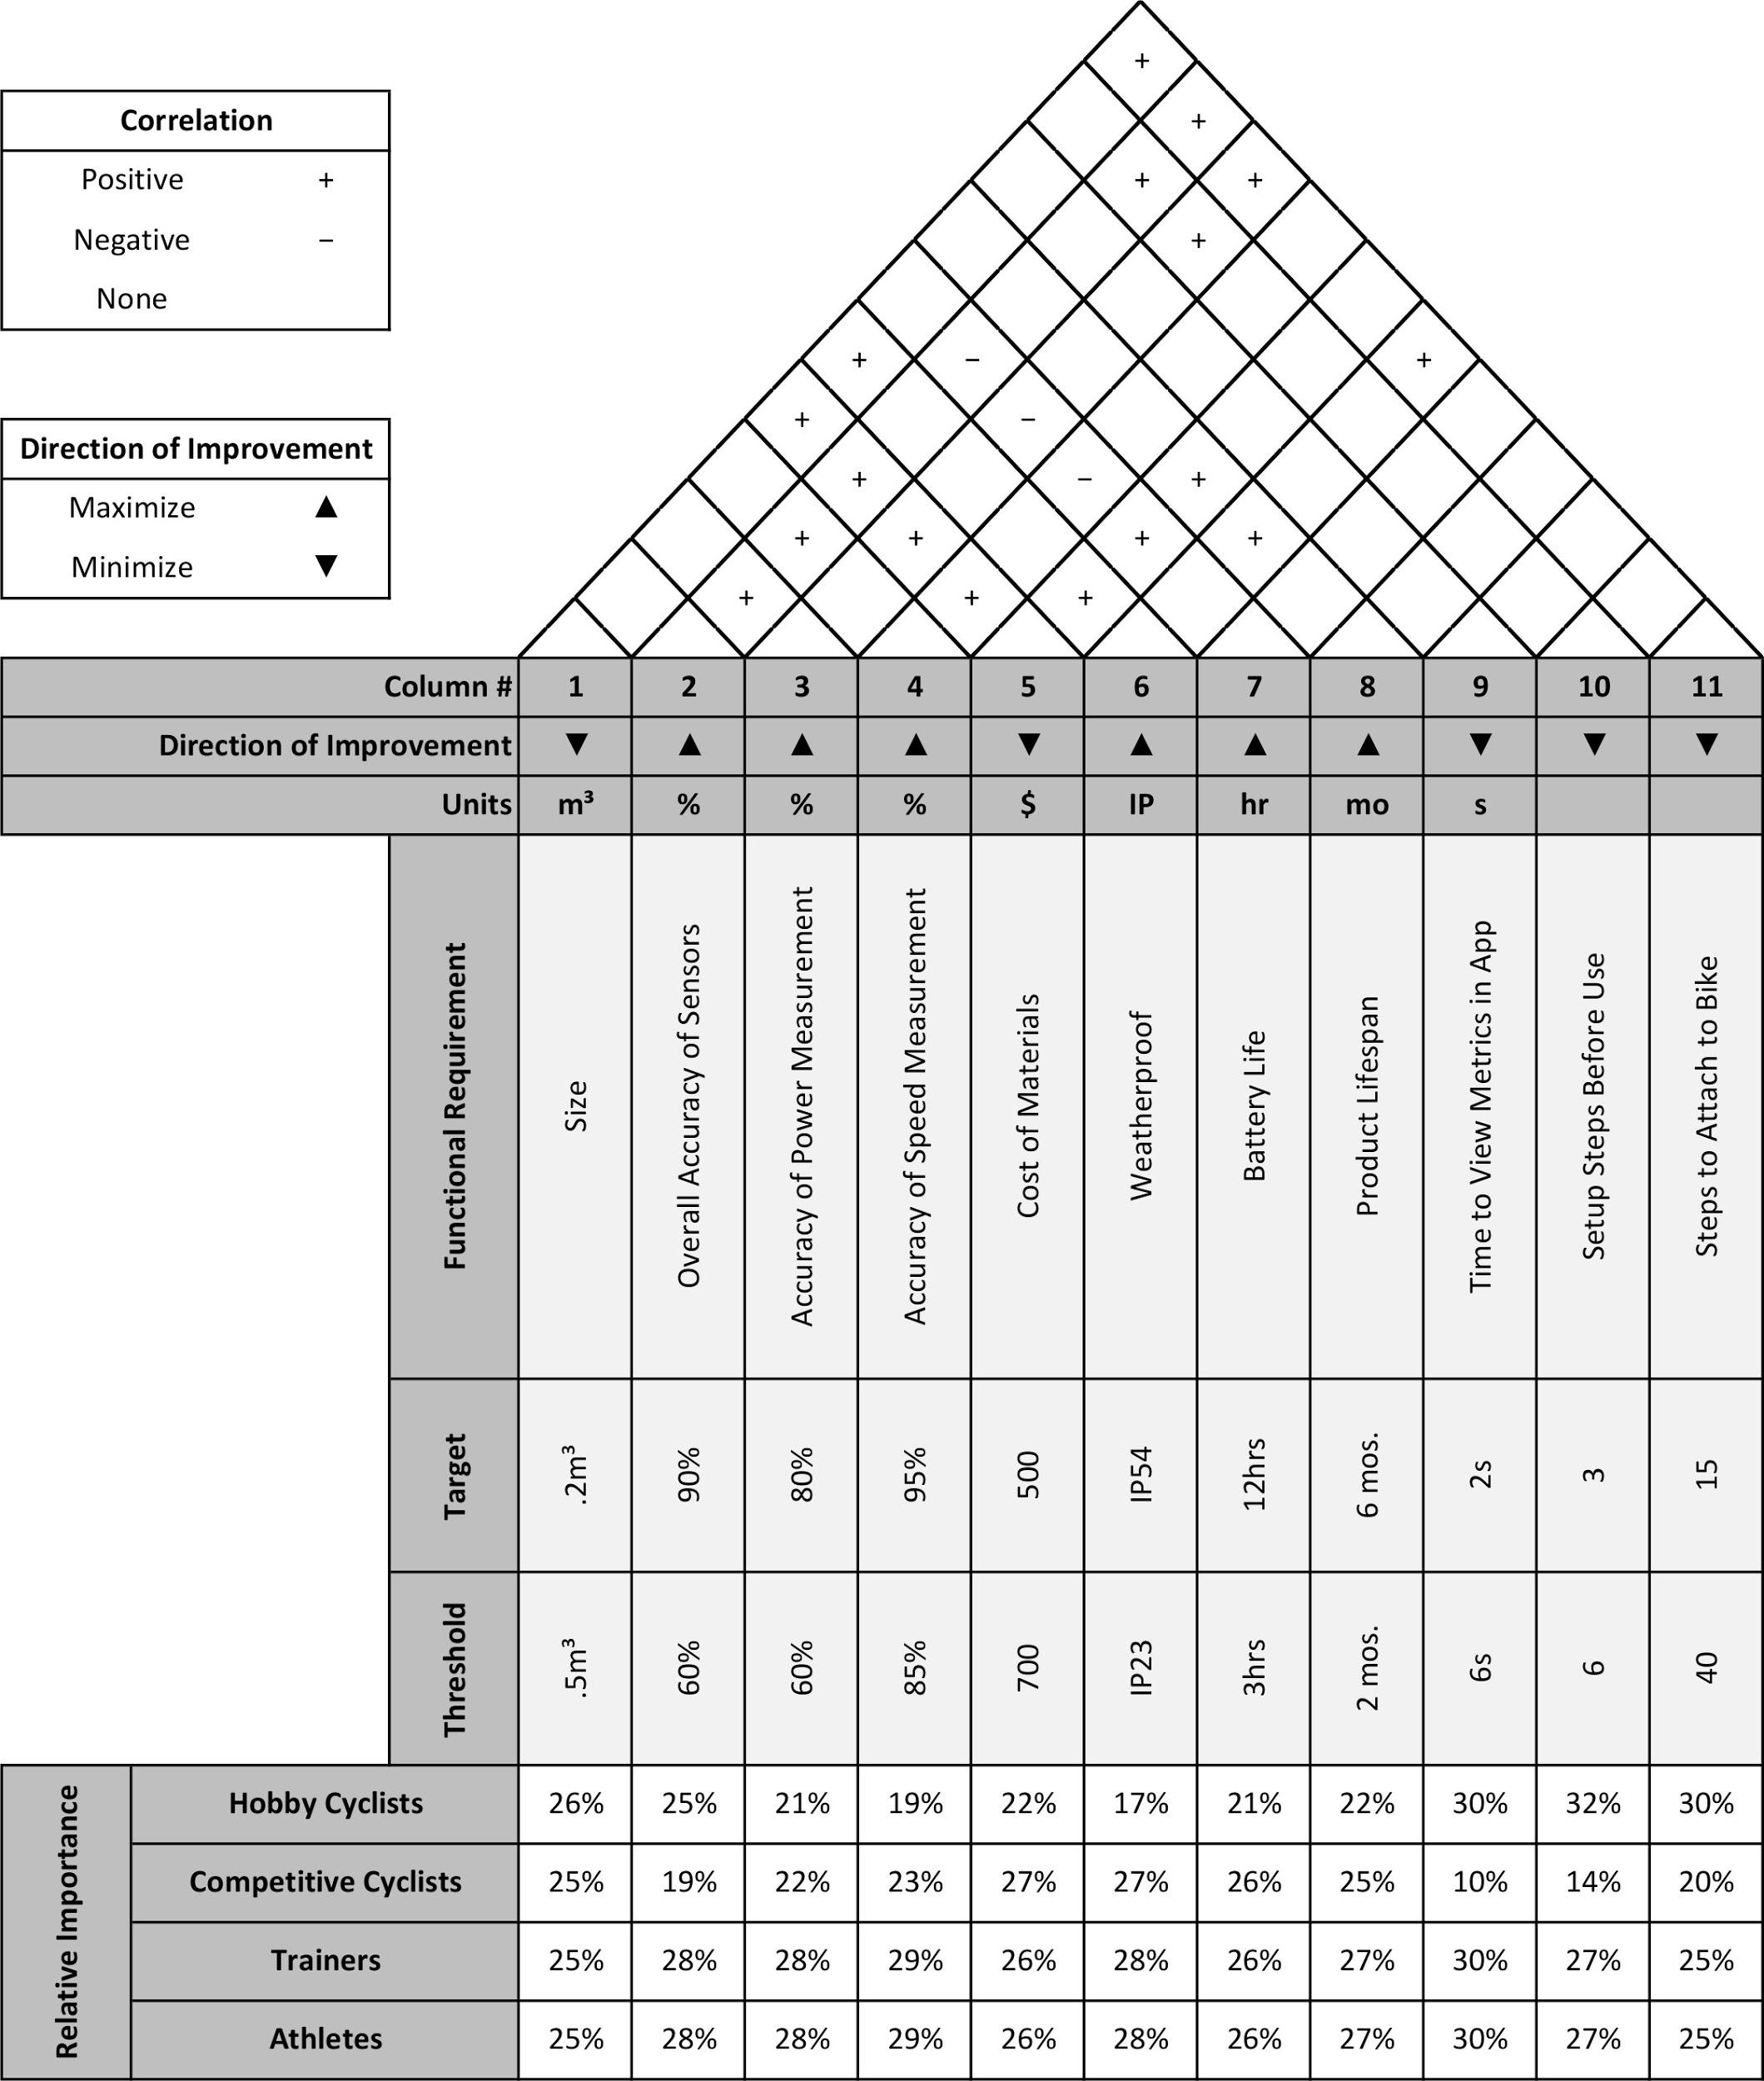
Figure 6: House of Quality (top view)

Impact:
The greatest potential impact of the Cycle Statistic Tool would be causing the bicycling activity tracker market to become more competitive. Results from this may include a decrease in product cost and a wider range of functionality across the market.
The Cycle Statistic Tool has the ability to enable positive growth in health awareness within society. The experience provided will also promote a healthy lifestyle through physical exercise for the user. For athletes, the project provides a method for advancing a user’s cycling skills. Additionally, the project may expand the usage of bicycles throughout the world. In the most radical instance, the project may increase the amount of bicycles being used within roadway systems. This could be a dramatic shift in transportation for some urban areas, which would require the development of more bike lanes.
The production of the Cycle Statistic Tool will cause some pollution. Electronic components required for the device will use rare earth metals acquired from mining the Earth’s crust. Additionally, the manufacturing of these components will release pollutants into the atmosphere. The device itself is produced using batteries, electronic sensors, and plastics which are hazardous for the environment. During operation, these components will not have much effect on the environment; however, if the device is not disposed of properly whenever a user retires their Cycle Statistic Tool, the hazardous components will cause pollution. This can be mitigated through proper recycling of the product.

Safety:
Manufacturing the Cycle Statistic Tool does expose the assembler to some safety hazards. Handling electronic circuits exposes the assembler to the flow of electricity. An assembler should never assemble any parts of the device while power is applied to it and power should not be applied until after the assembler has finished and carefully checked the circuit. If a burning smell is noticed, the assembler must immediately remove power and review the circuit for any issues that occured. Additionally, general safety precautions should always be enacted, such as wearing safety goggles, ensuring the work area is dry and well ventilated, and staying in close proximity to safety equipment.
If the Cycle Statistic Tool is not properly disposed of, specific components used in the device will not only be an environmental risk, but also a health risk. Lithium-ion batteries will decay and leak if disposed of improperly, which can pollute soil and water. Not only is this a potential risk for the environment, but also to organic life that may be exposed to these pollutants. The improper disposal of the electronic components and plastics from the Cycle Statistic Tool have a similar result. Many electronic components include lead, mercury, and plastics, which are hazardous materials. Additionally, the burning of plastics can cause cancer.

Conclusion:
The Cycle Statistic Tool will provide an experience with more features than competing
products at the same price point. In the current market, pedal shafts that measure power start
around $350, but they are limited to only measuring power. Currently there are no products
that measure wind direction, wind speed, or gear ratio. The Cycle Statistic Tool will offer these measurements, along with data offered by general-purpose activity trackers at the same price point.

